Link manual Editora CD PRESS-AICI: https://cdpress.ro/clasa-a-v-a/3118-educatie-fizica-si-sport-manual-pentru-clasa-a-v-a.html
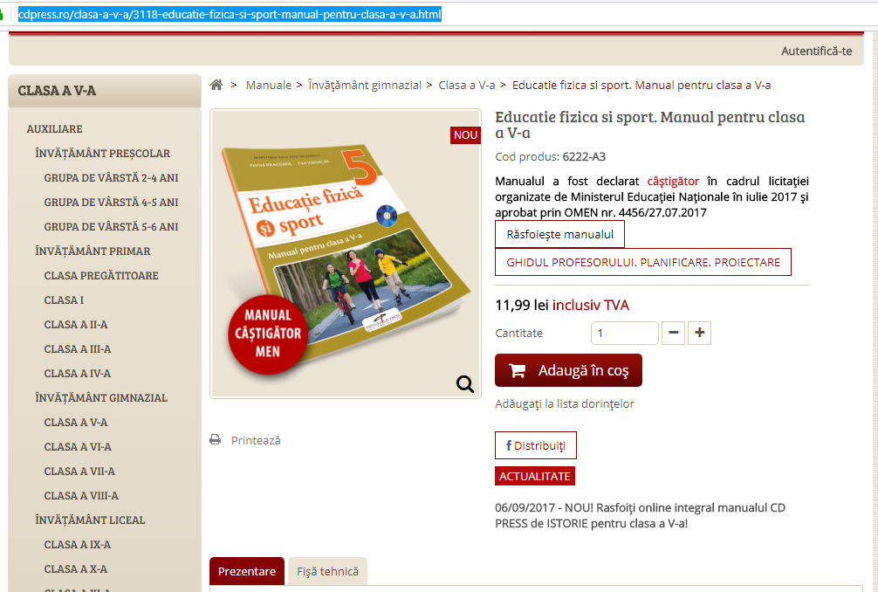
Link manual variant digitala interactiva-AICI: https://manuale.edu.ro/manuale/Clasa%20a%20V-a/Educatie%20fizica%20si%20sport/CD%20Press/
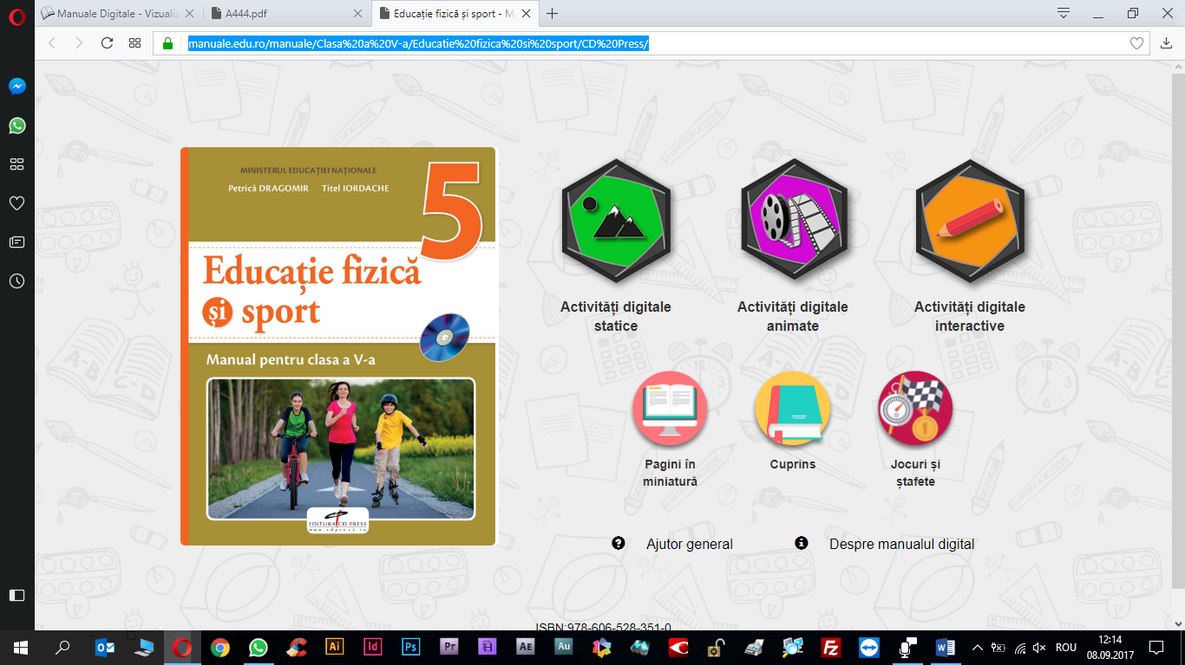
Link descărcare manual format pdf-AICI: https://manuale.edu.ro/manuale/Clasa%20a%20V-a/Educatie%20fizica%20si%20sport/CD%20Press/A444.pdf


